**Lecture 68:** To design the below distributed services

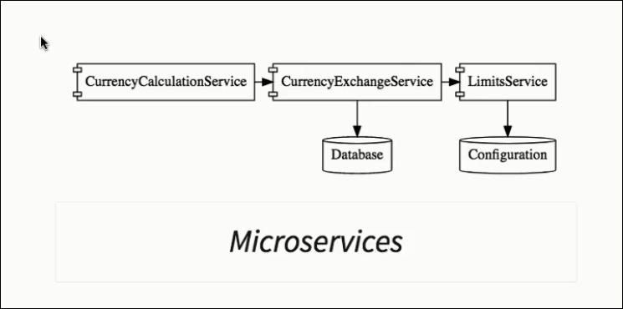

**Lecture 69,70,71:Setup currency-exchange-service**

**Action1: Create currency-exchange-service**

**Step1: Download the configured springsboot project**

**\*\*Note:** we need **Config Client** here & Spring-Boot version same as other services ( currency-conversion , limit-service etc) .Also artifact name to be consistent across usage.

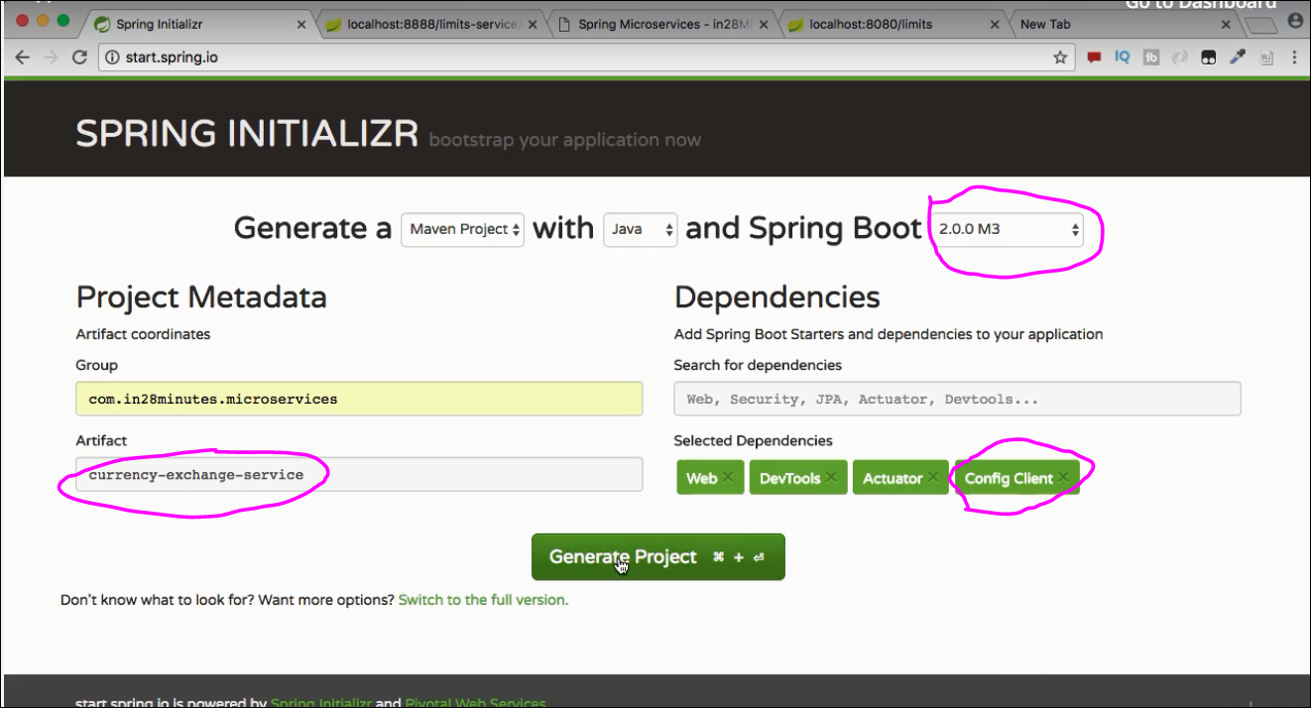

**Step2: Import it to workspace as existing Maven project**

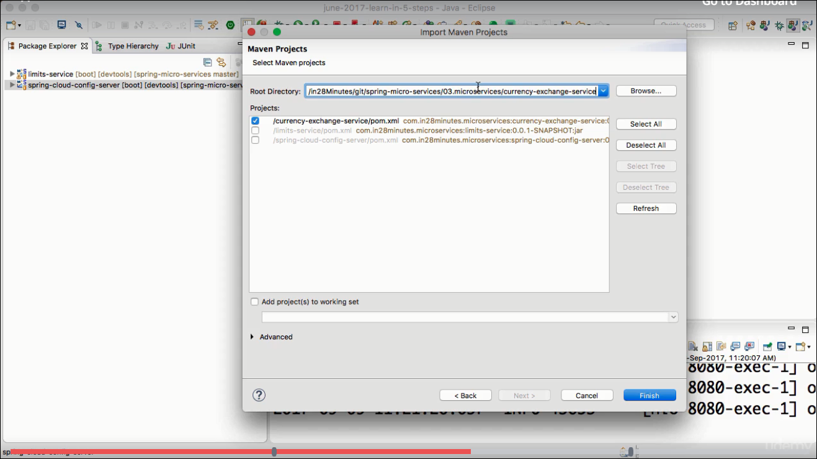

**Step3: set application name & port**

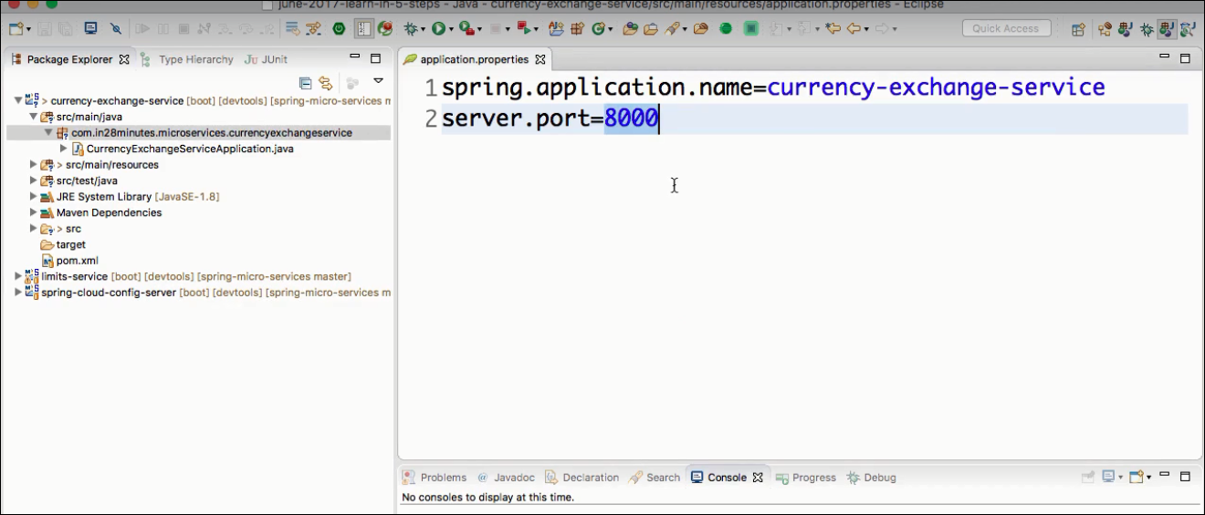

**Step4: Add currency controller functionality**

**Define controller:**

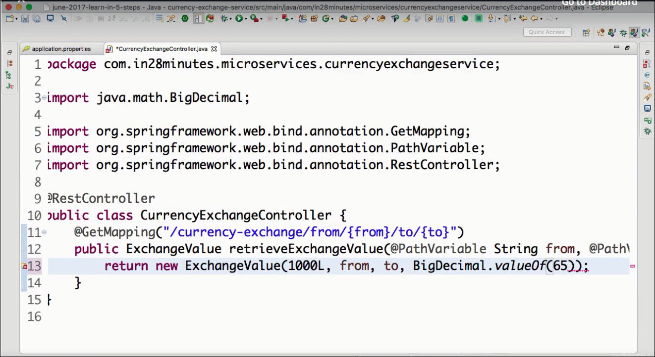

**Define Bean:**

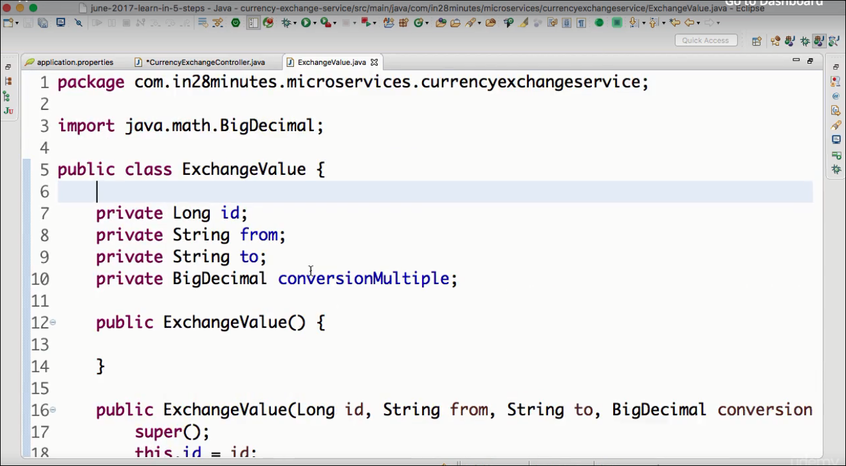

**Test the Currency Exchange service:**

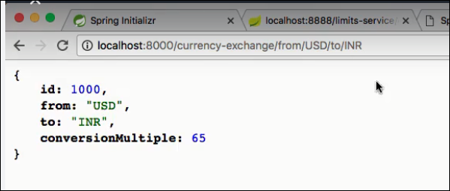

**Action2: setup dynamic port in the response of currency-exchange-service**

**Step1:** Add port to the ExchangeValue bean , add its getter setter but dont add in constructor.

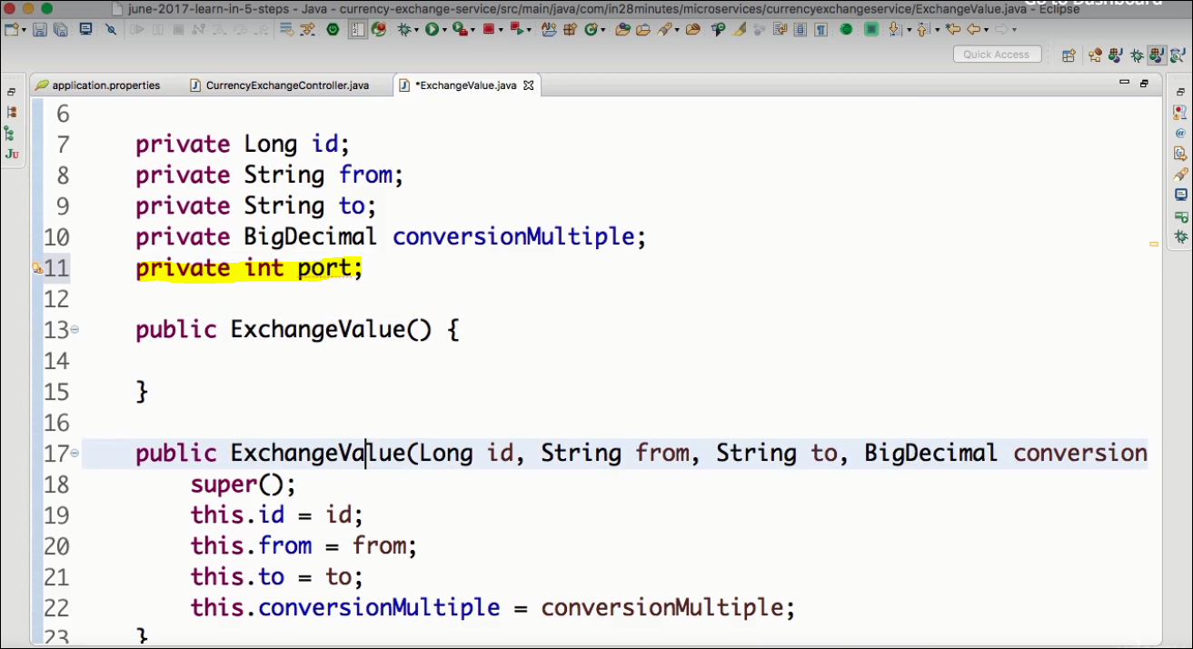

**Step2: Add the local.server.port property to the response in Controller:**

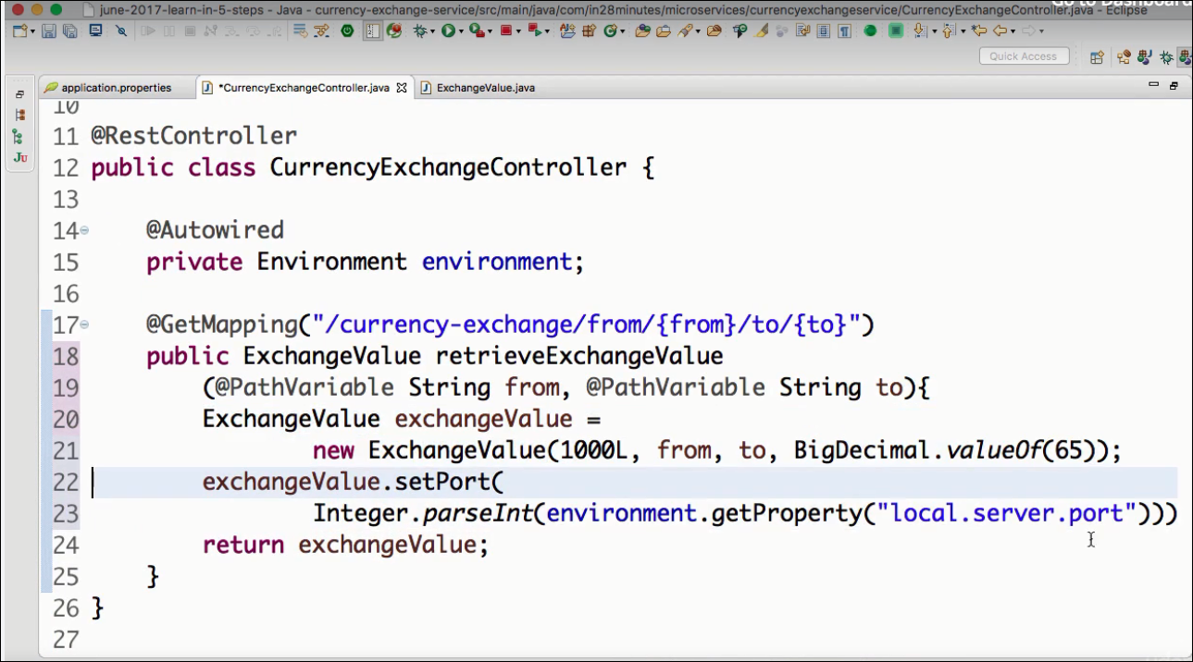

**Step3: Test to see the port value in response**

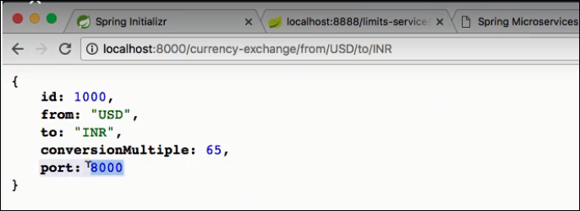

**Step4: To run this application on different port create separate run configurations.**

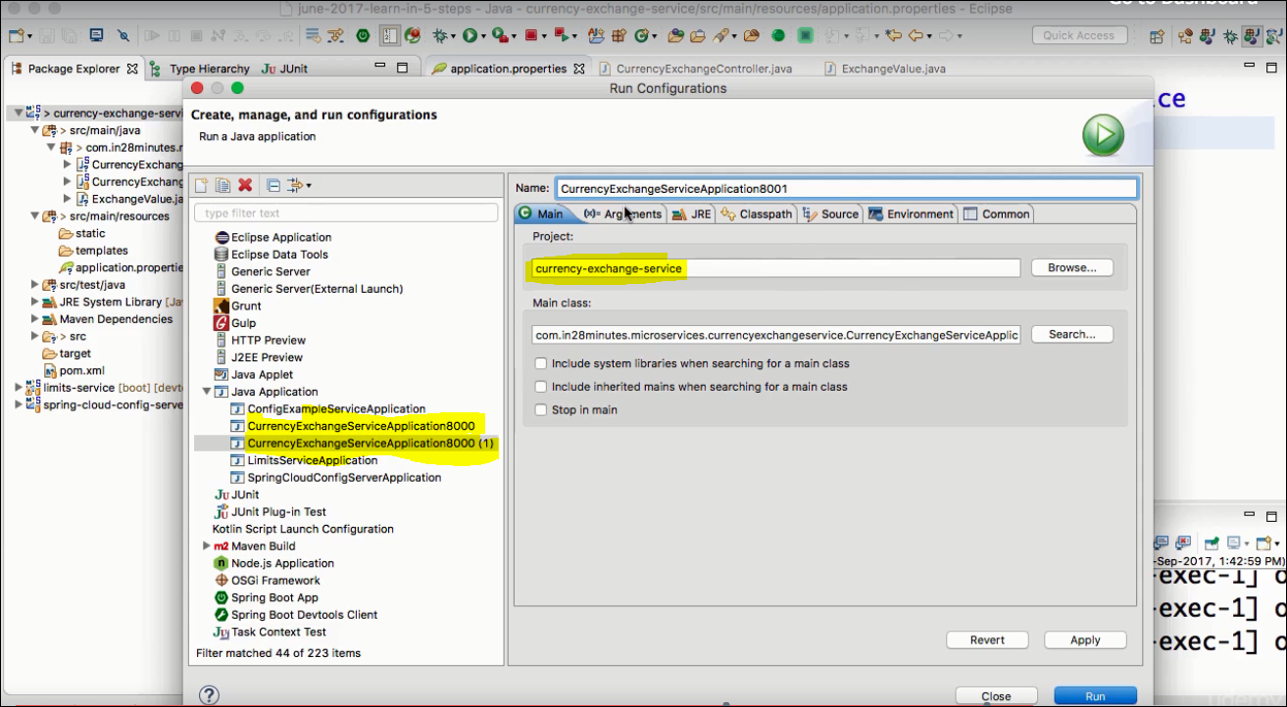

**Pass the VM Arguments as shown below:**

**Verify the response on both the ports:**

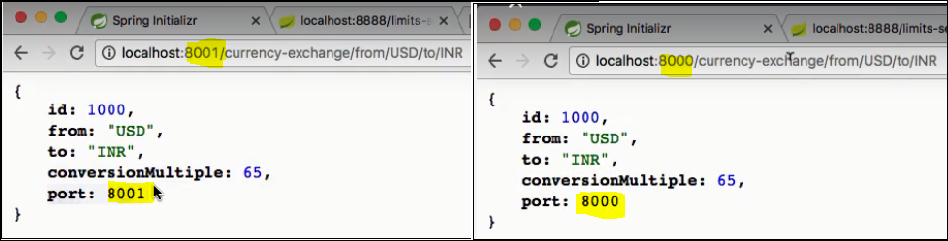

**Lecture 72**

**Action 3: Configure JPA & Initialize data & add JPA repository**

**Step1: Add dependency in pom.xml**

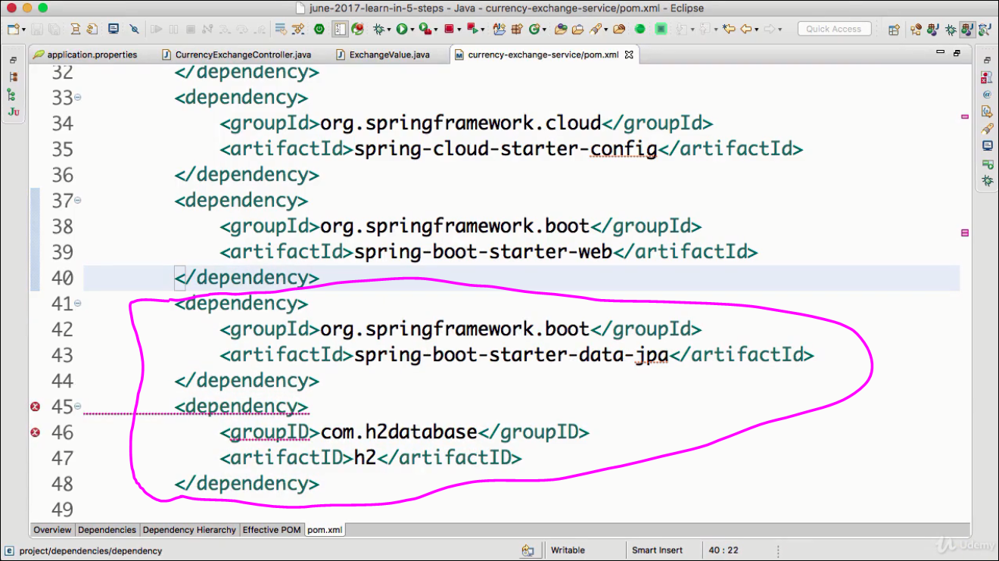

**Step2: Add Entity**

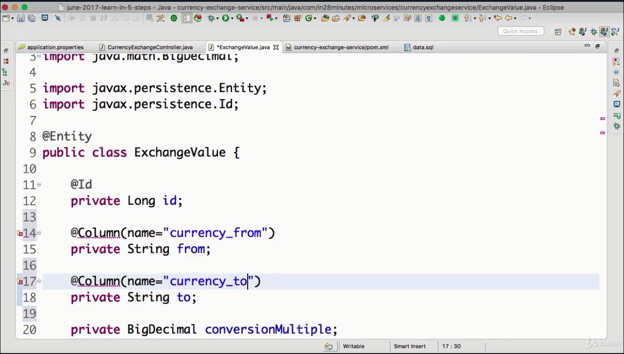

**Step3: Add the file data.sql & add following sql to it:**

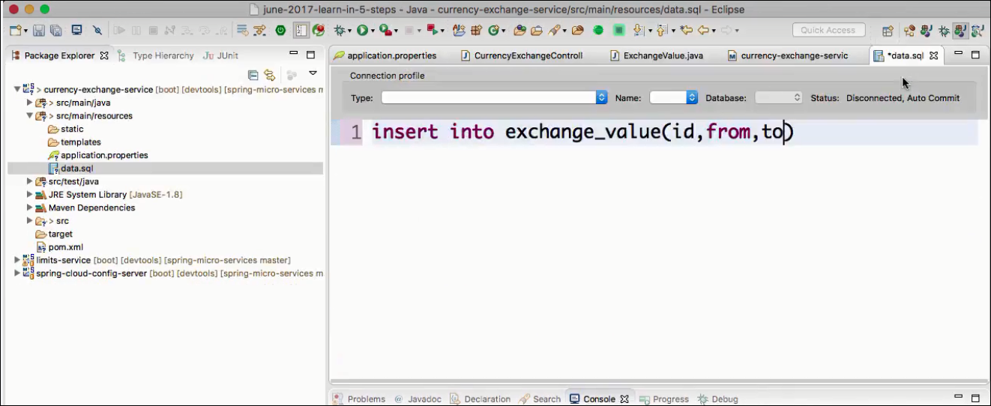

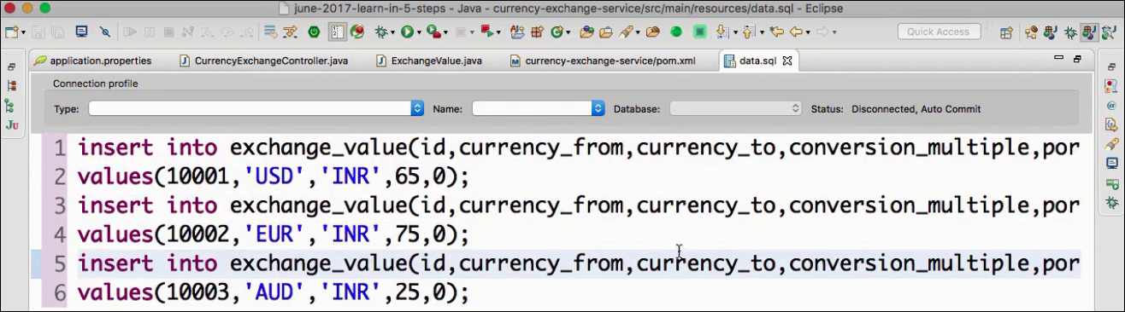

**Step4: Restart the application**

**Step5:Verify that the table is created in the H2O console:**

**URL:http://localhost:8000/h2-console**

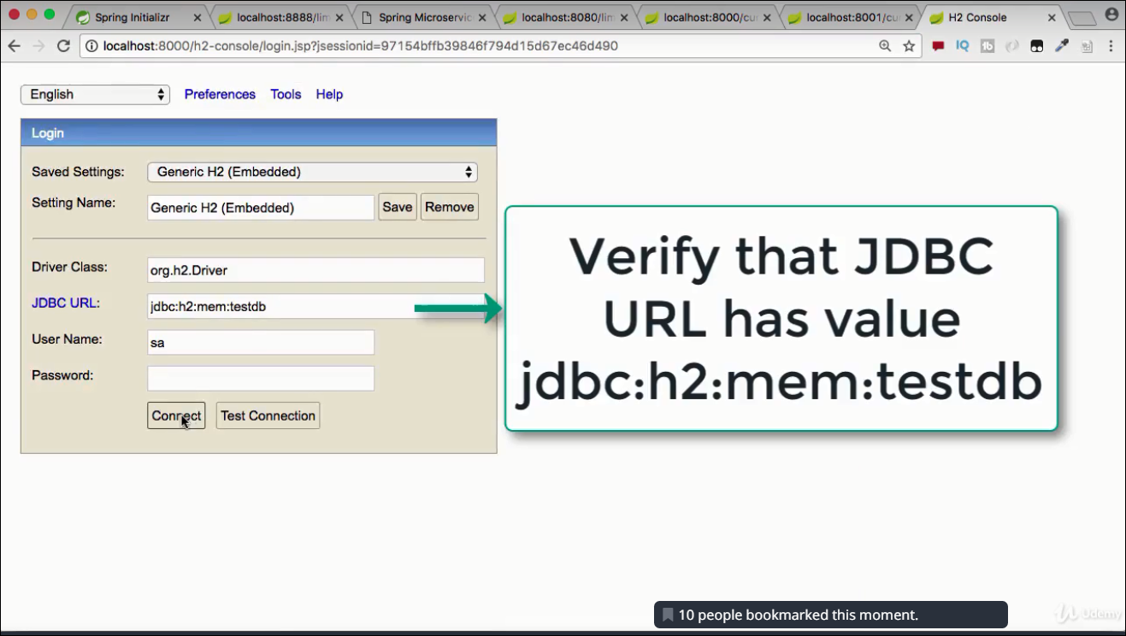

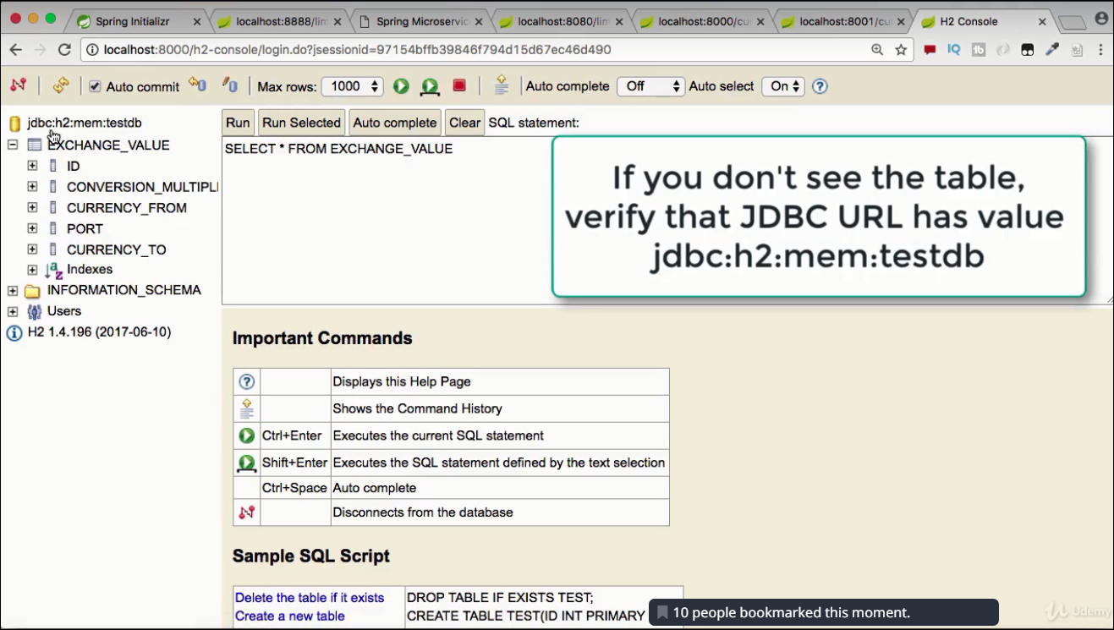

**Lecture 73: Add JPA to currency Exchange service( I.e Create a JPA repository )**

**Step1: Add JPA repository (a Spring-Data project)**

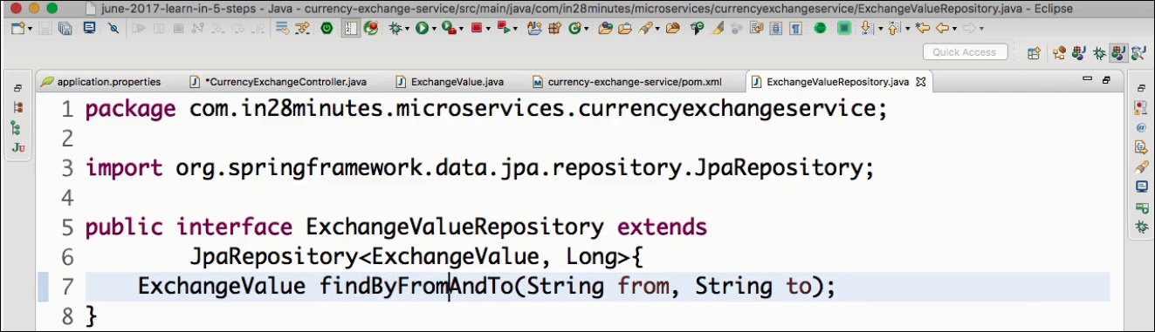

** findByFromAndTo → JPA in Spring -Data will implement the method to find By From & To.

**Step2:**

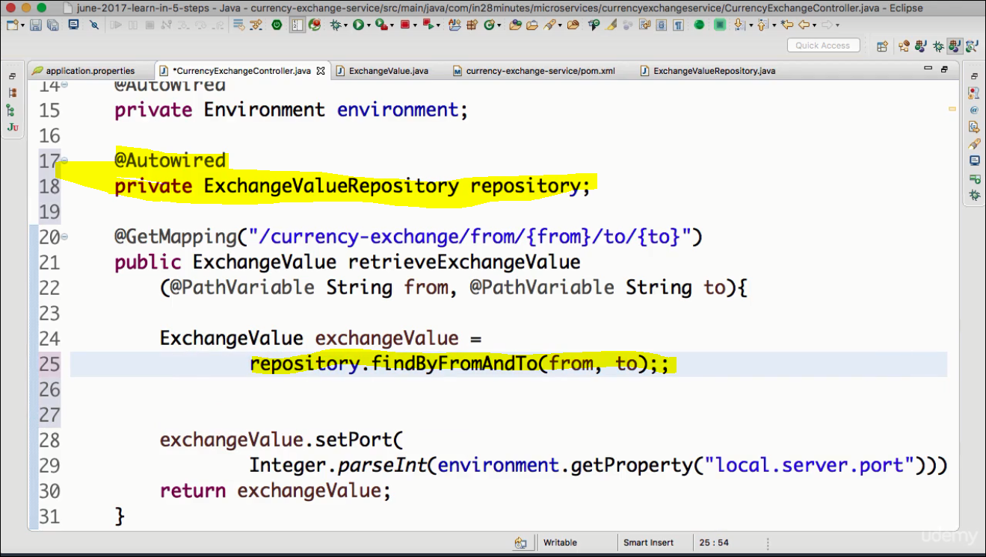

**Step3: Restart Application & test it on Browser**

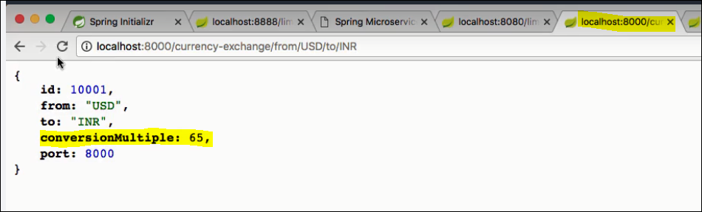

**Test it with another From & To:**

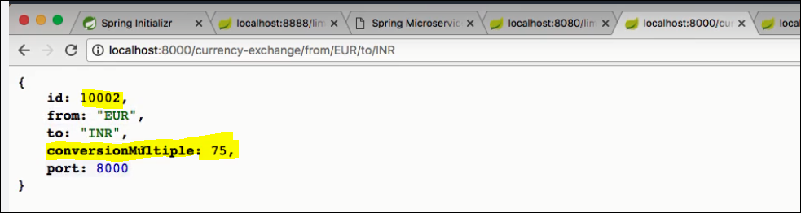

**Lecture 74: Setup Currency Conversion Microservice**

**Step1: Download the project from Spring boot initializer**

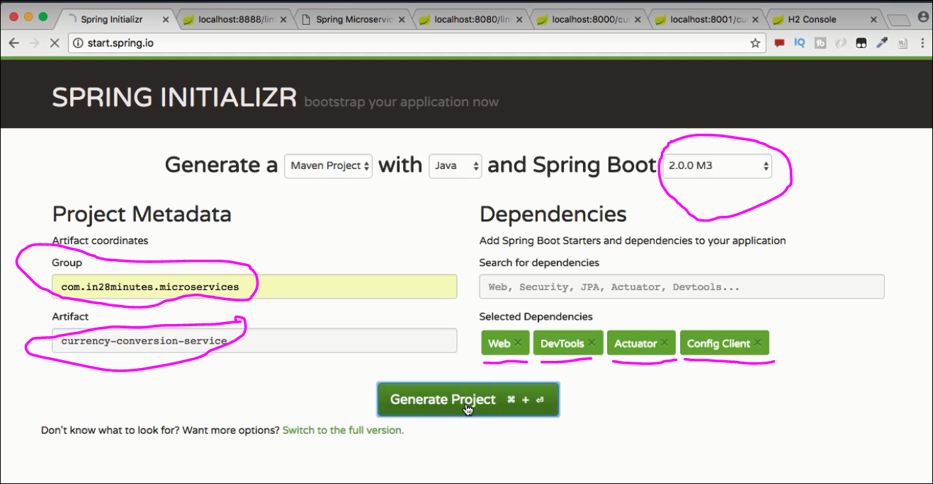

**Step2: Import the downloaded project**

**File → Import → Existing Maven Project → ( below)**

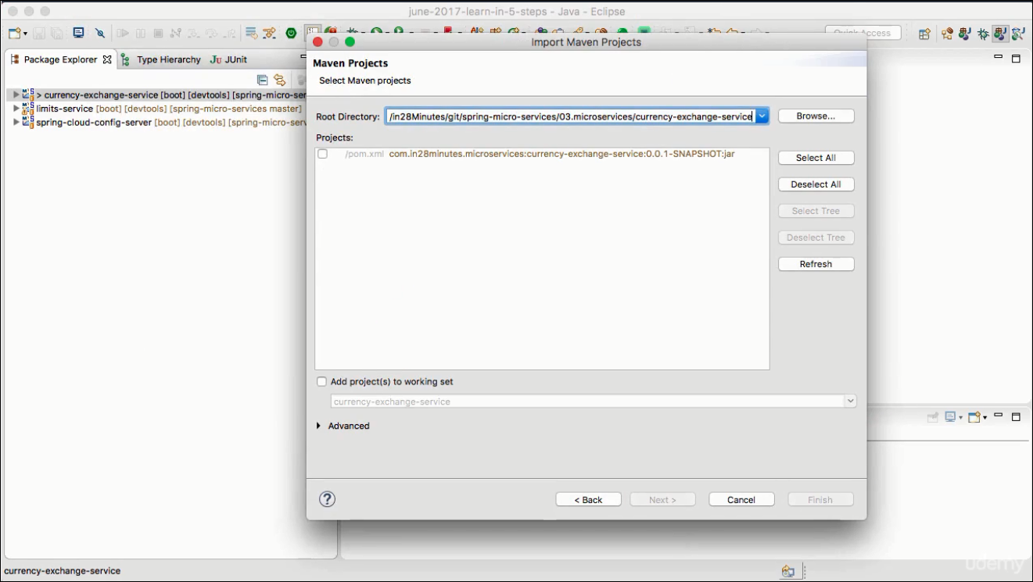

**Step3: Configure the application:**

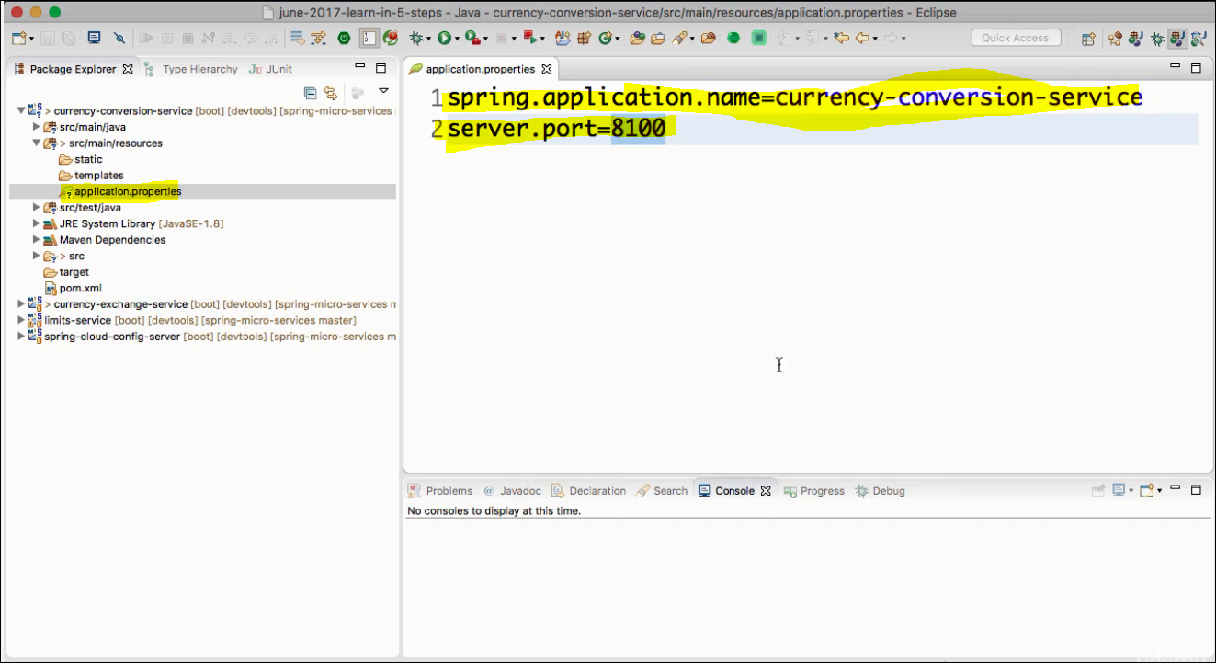

**Step4: Add Controller & Bean**

**As of now return a hard coded bean to test.**

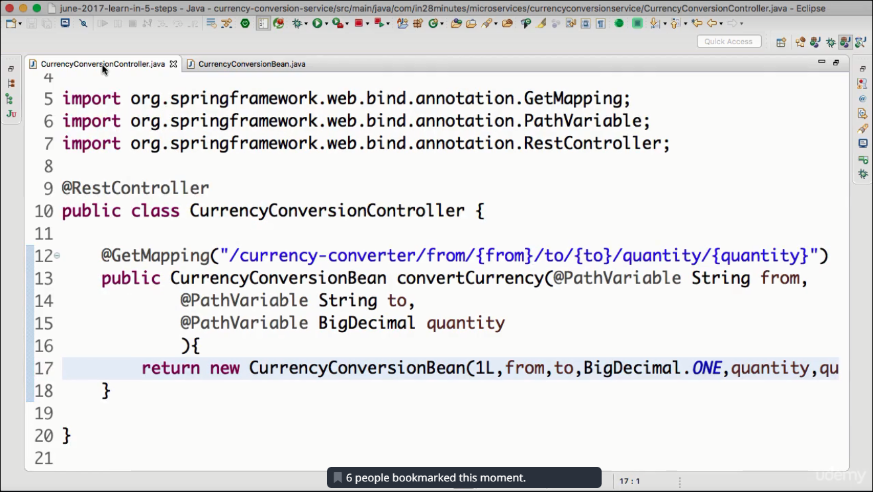

**Bean:**

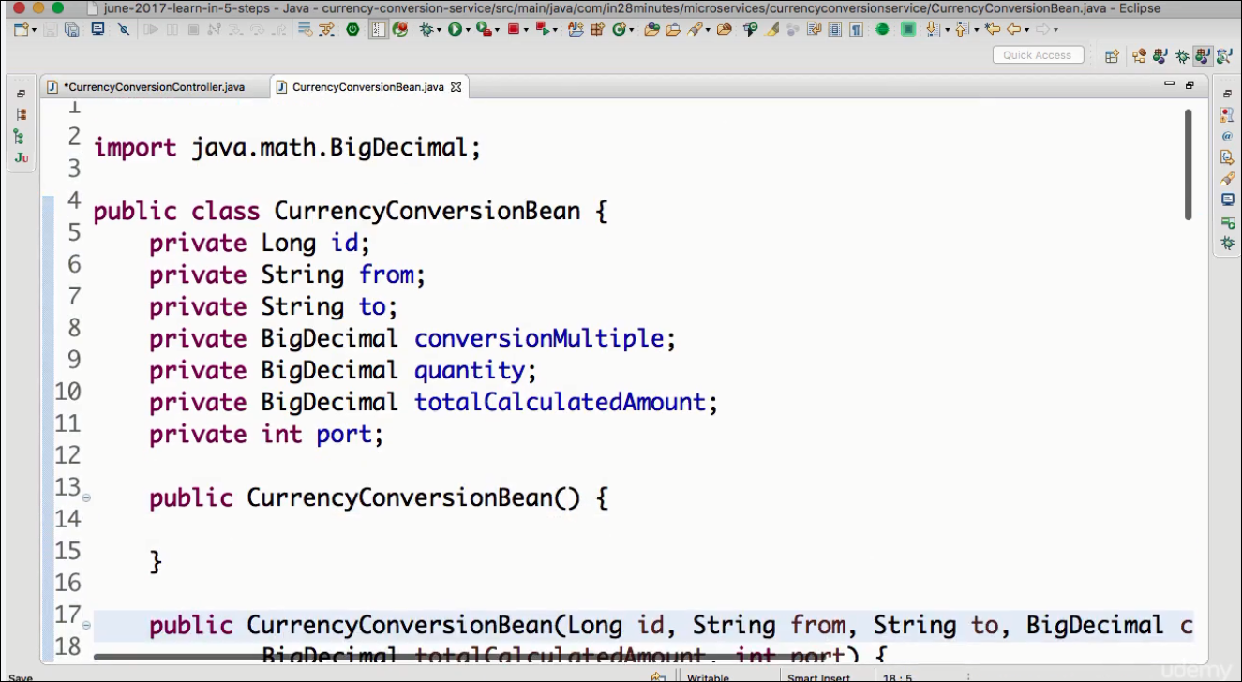

**Test:**

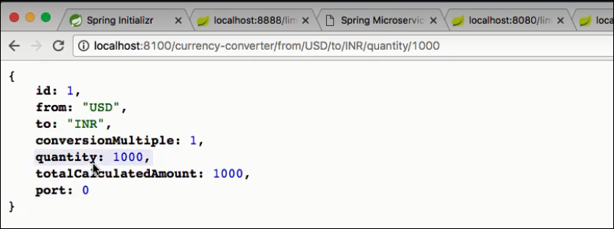

**Lecture 76: Invoke Currency Exchange Service from Currency Converter service**

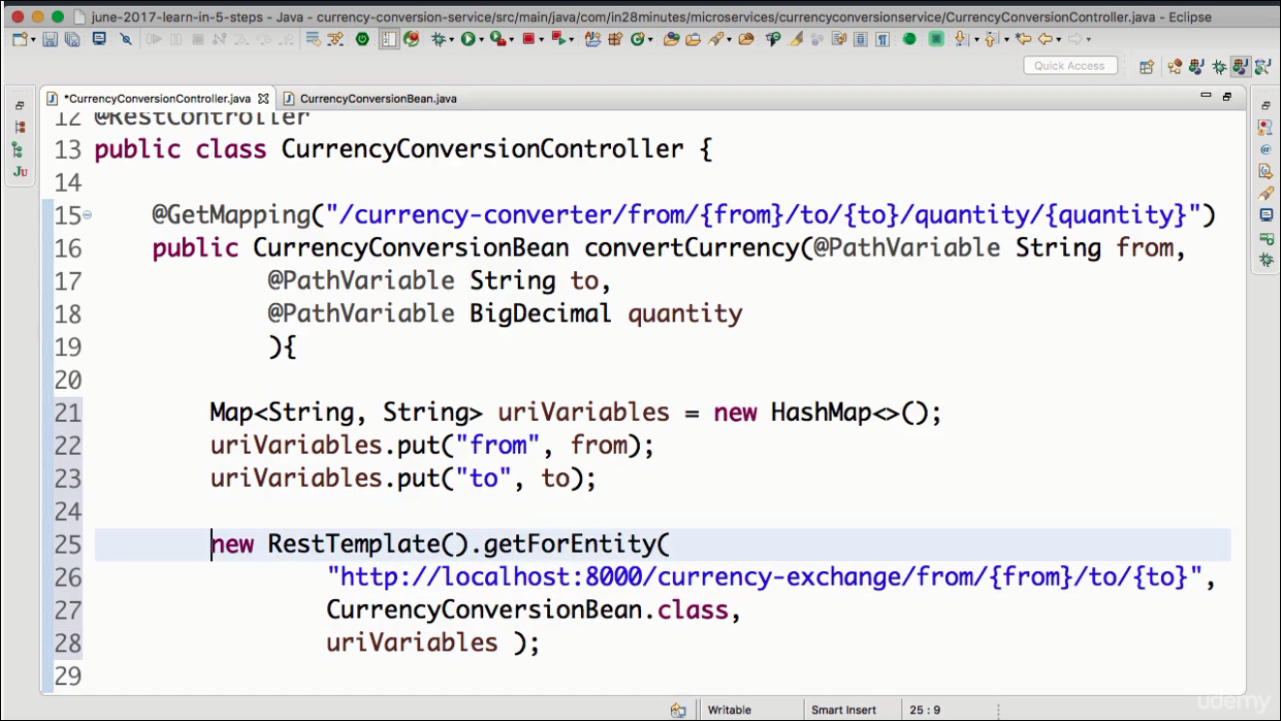

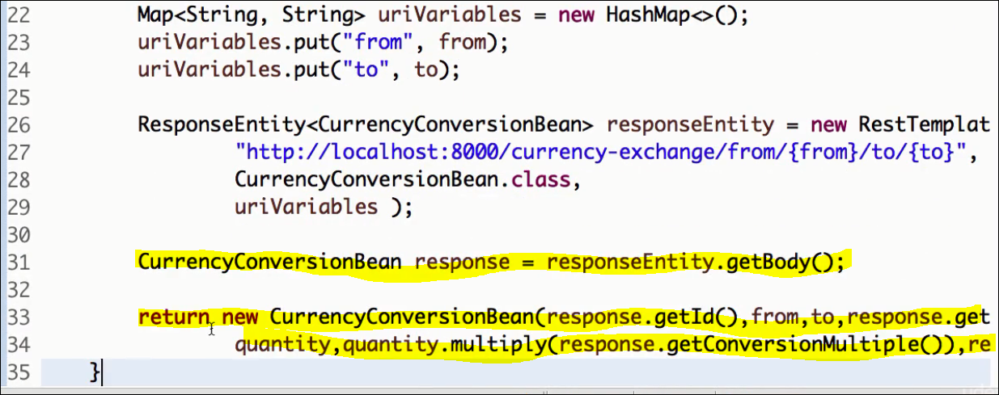

**Check the output:**

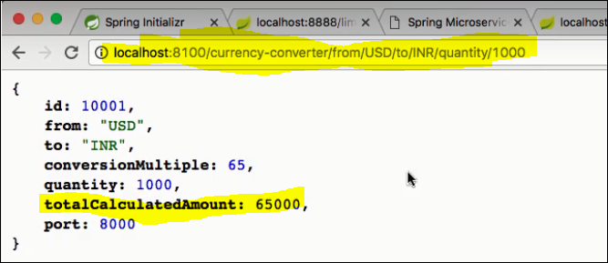

**\*\*\*\*\*\*\*\*\*\*\*\*\*\*\*\*\*\*\*\*\*\*\*\*\*\*\*\*\***

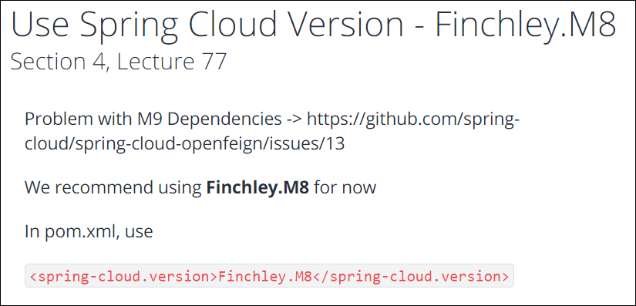

**Lecture 77 : Disclaimer to use Finchley.M8**

**Lecture 78: Using Feign REST Client.**

Feign helps to invoke other micro services , we need not write the below boiler plate code .

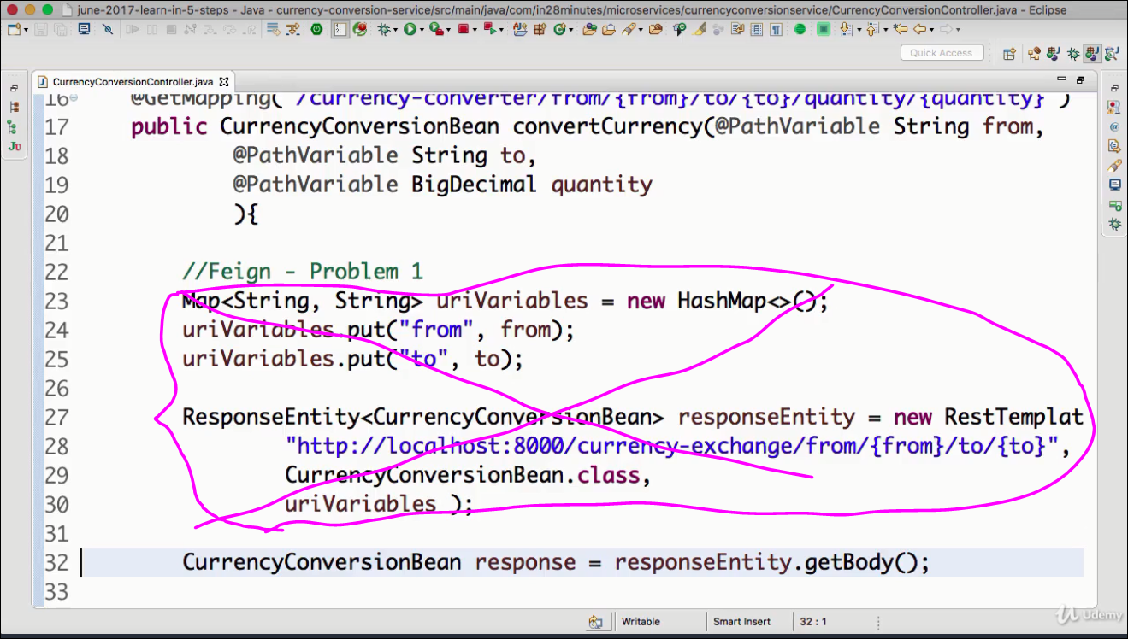

**Action5: Add Feign support**

**Step1:**

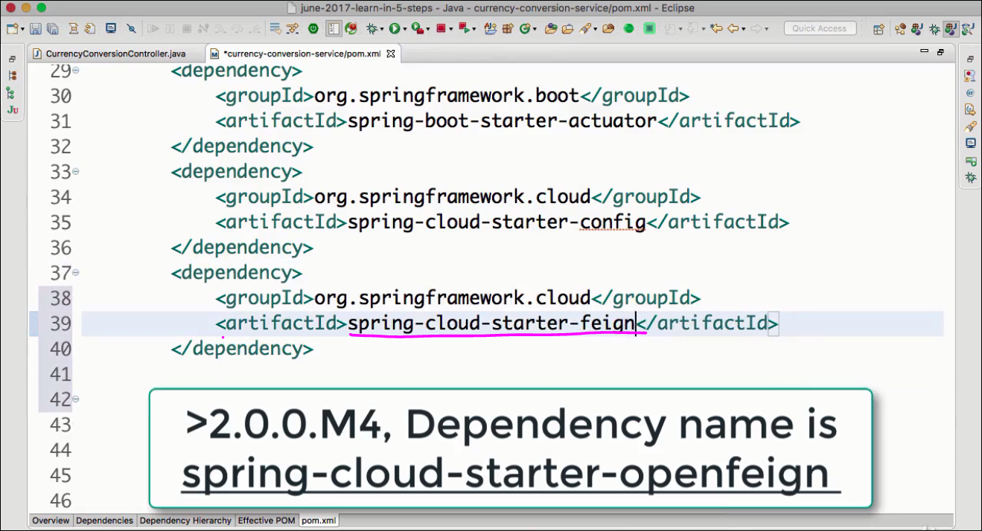

**Ensure Spring-cloud dependency is present:**

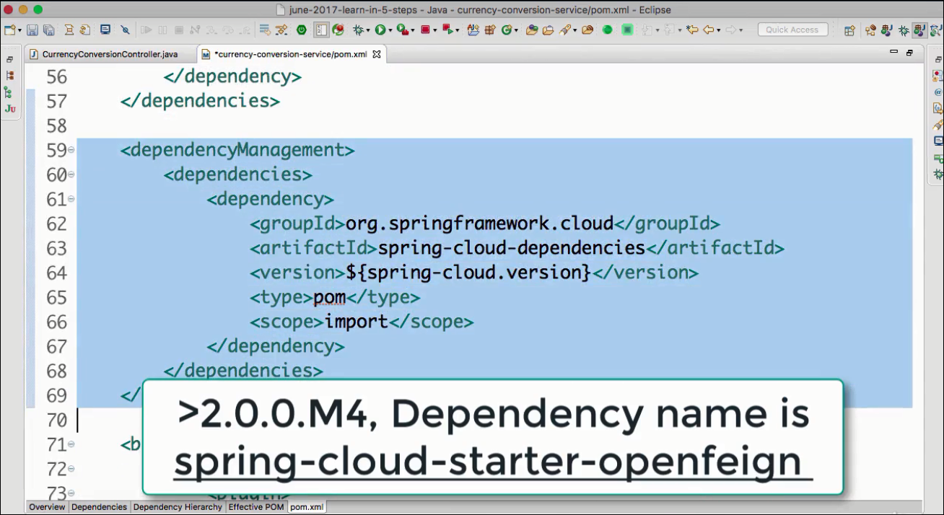

**Step2:**

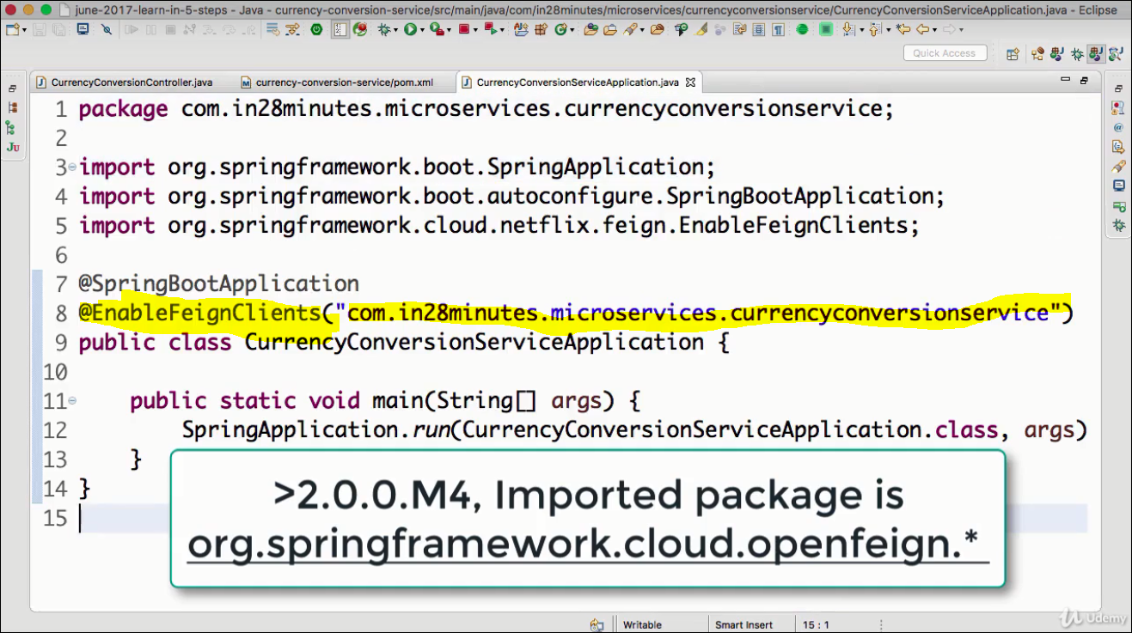

**Step3: Create a feign proxy**

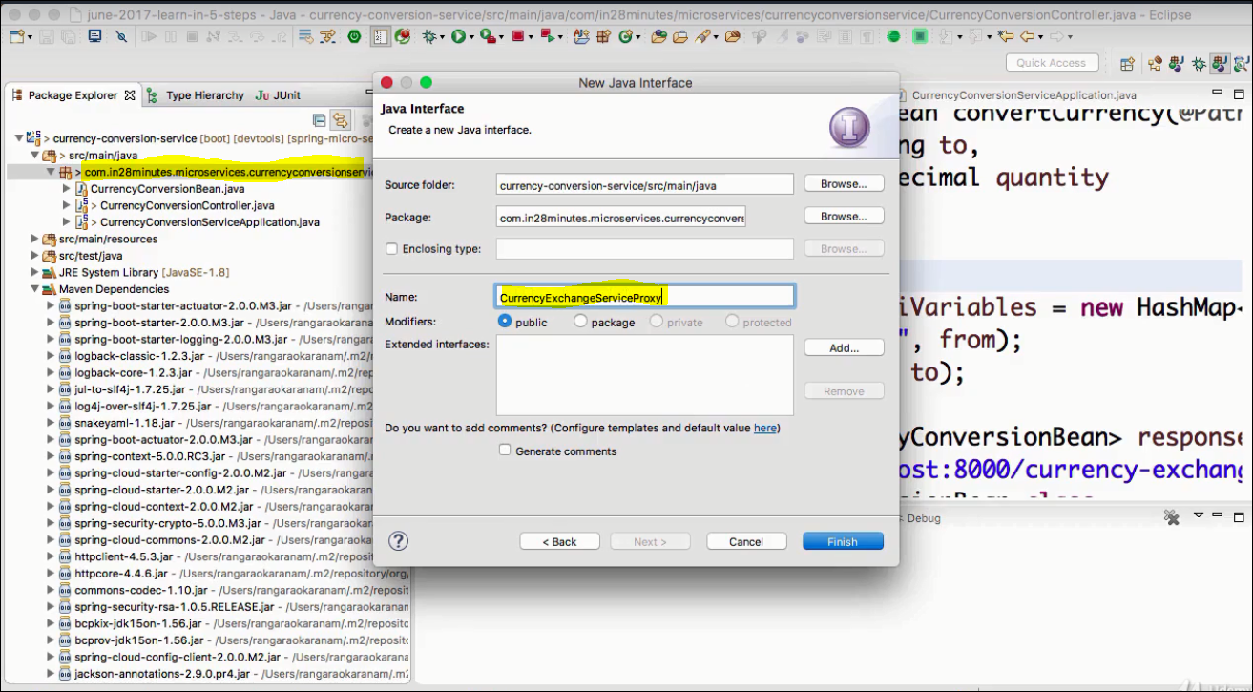

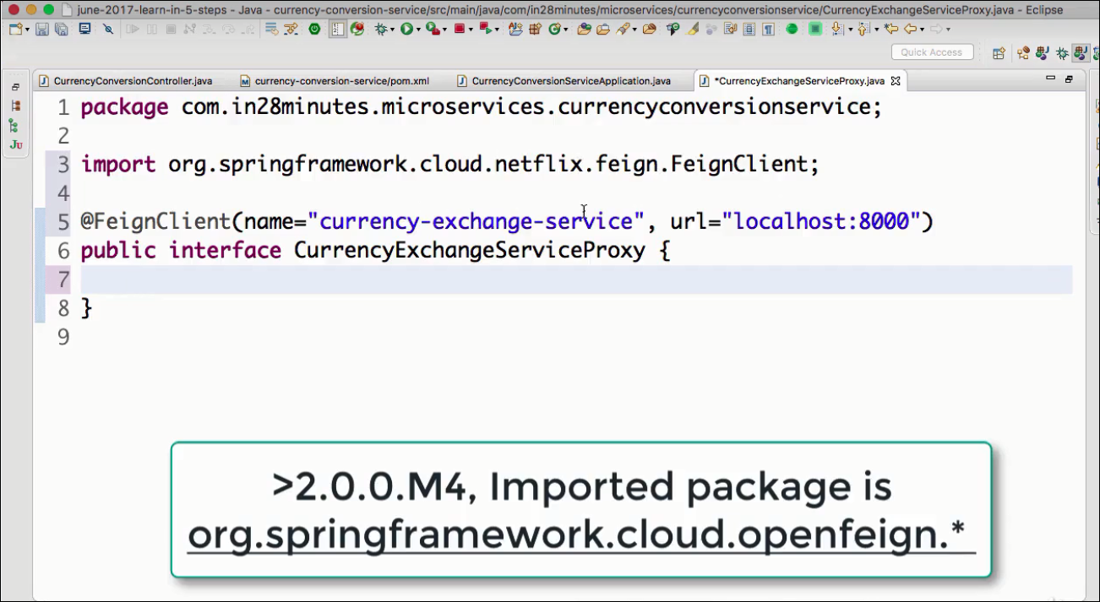

**Define the implementation services: We copy the method that would get called from the CurrencyExchangeServiceController & twik a bit.**

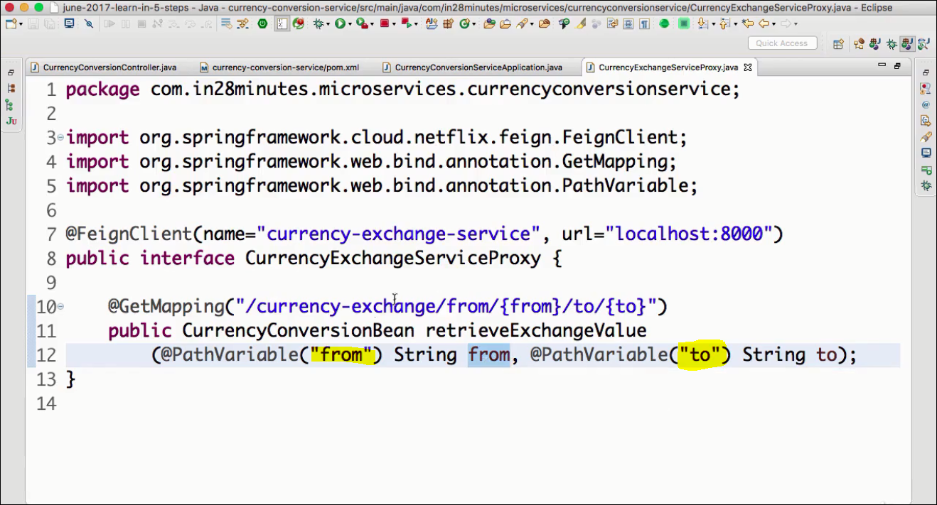

**Step2: Add the ref in the Controller**

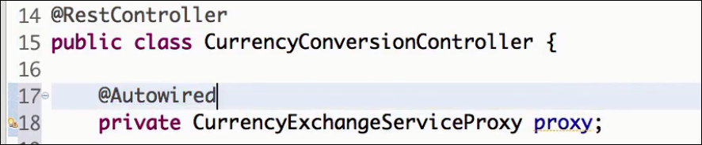**Step3: Copy the existing convertCurrency to convertCurrencyFeign**

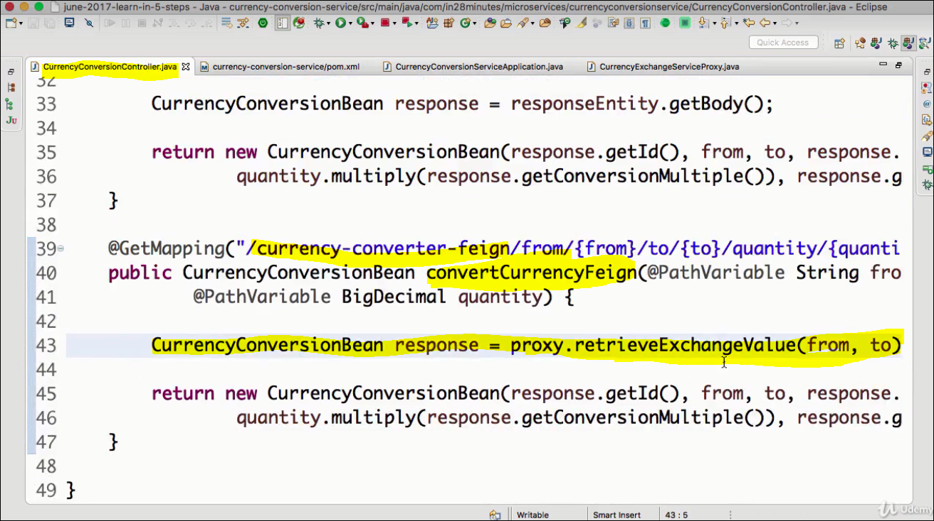

**Step4: Restart CurrencyConverterService and test:**

